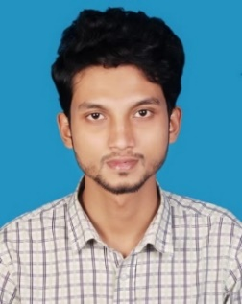CURRICULUM VITAE OF

Md. Kawsher Hamid Mazumder

Address: Block-4, Navana Tower, Bashabo, Dhaka-1214.

Telephone: 01799397962

Email: [kawsher.98@gmail.com](mailto:kawsher.98@gmail.com)

OBJECTIVE

I'm looking for a company where I can prove myself as a potential employee and can gives appropriate support to the clients along with the organization.

EDUCATION

B.SC. IN COMPUTER SCIENCE & ENGINEERING | SOUTHEAST UNIVERSITY

Year: 2014-2018

CGPA 3.14 out of 4.00

HSC | Dania College | Board: Dhaka | Group: Science.

Year: 2012.

GPA: 5.00 out of 5.00.

SSC | Barnamala Adarsha High School | Board: Dhaka | Group: Science

Year: 2010.

GPA: 5:00 out of 5.00.

SKILLS & ABILITIES

* Language: PHP, C, C++, Java.
* Framework: Spring Boot, Laravel, Angular 6, HTML, CSS, Bootstrap.
* Content management system (CMS).
* Office: MS Office, Excel, Outlook.
* Database: MySQL, NoSQL (MongoDB)
* Operating System: Windows, Linux, MacOS.

EXPERIENCE

Junior Software Developer | Majumder Global | January 01, 2019 – Present

I have been working on website development in Majumder Global farm as a full stack web developer.

# Training Experience:

Internship in IT department, Social Islami Bank Limited. From Oct 2018 - Dec 2018.

# Projects:

* Event Management System (GitHub Repository: <https://github.com/kawsher-hamid98> )
* Employee management system (GitHub Repository: <https://github.com/kawsher-hamid98> )

# Personal Information:

Father Name: Md. Rahim Ullah Mazumder

Mother Name: Masuda Sultana

Data of Birth: 08-06-1994

Nationality: Bangladeshi

Marital Status: Unmarried

Religion: Islam

Blood Group: A+

# References:

* Md. Ashiqur Rahman

Assistant Professor

Department of Computer Science & Engineering

Southeast University

[ashiqur.rahman.cse@gmail.com](mailto:ashiqur.rahman.cse@gmail.com)

* Shahriar Manzoor

Acting Chairman and Associate Professor

Department of Computer Science & Engineering

[smanzoor@gmail.com](mailto:smanzoor@gmail.com)